**Git commands**

**git checkout master**: to change the batch to master

**git pull** : update our local repository with the latest changes from the remote repository.

**git checkout -b data_eda :** creates a new branch named "data_eda" and switches to that branch

git commit -m "added data_eda jupyter notebook"

git push

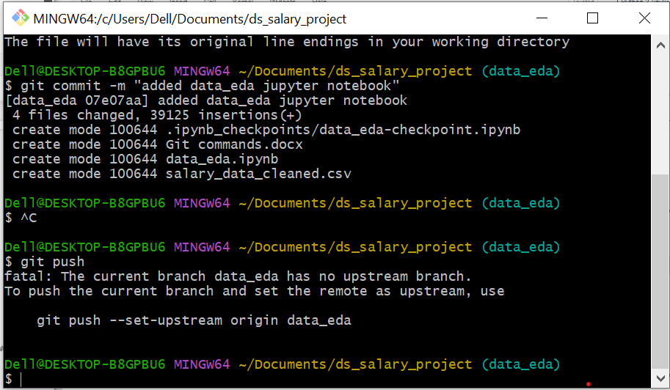

git push --set-upstream origin data_eda

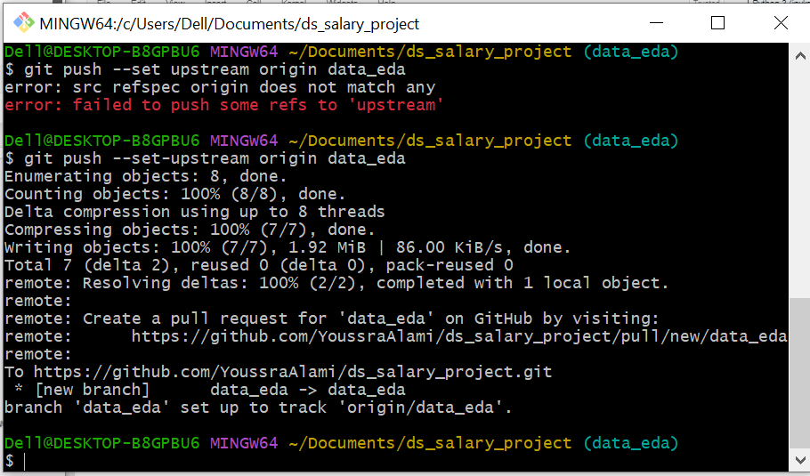

git checkout -b model_building

